Department of Computer Science and Engineering
(AI & ML)
B. Tech. CSE - 5th Semester
Aug – Dec 2025

UE23CS351A
DATABASE MANAGEMENT SYSTEMS (DBMS)

PROJECT REPORT on

CampusConnect – A College Professional Networking Platform

Submitted by:
PES1UG24AM077 | Deana Naveen A | 5 B
PES1UG24AM068 | Bhoomika Kshatriya | 5 B

Class of Prof. Smitha G R

Abstract

CampusConnect is a college-oriented professional networking platform inspired by professional networking applications. It allows users to create profiles, list education and work experience, add skills, connect with other users, share posts, interact through likes and comments, explore job opportunities, and receive skill-based job matching information. The application is implemented using Python Flask with HTML/Jinja templates and CSS.
The project demonstrates a multi-database architecture. MySQL stores structured and transactional information such as users, companies, education, experience, skills, connections, jobs and applications. Redis stores activity-oriented data such as posts, likes, comments, hashtags, feeds, messages, notifications and leaderboards. Neo4j represents relationships as a graph and supports graph-oriented reports and recommendations. MySQL remains the source of truth, while the graph is synchronized from relational data.
The database design uses primary keys, foreign keys, unique constraints, CHECK constraints, indexes, views, joins, aggregate queries and stored procedures. Two application novelties are a skill-gap analyzer that compares a user's skills against job requirements and a 'People You May Know' recommendation procedure based on mutual connections, shared skills and common education. The report documents the requirements, data models, database commands, application structure and evaluation status based on the submitted project files.

Table of Contents
Sl. No | Topic | Page No.
Introduction
- Problem Statement
 | User Requirements Specification- Tech Stack
E-R Model
- List of Entities [labeling Weak ones]
- List non-simple Attributes
- ER Diagram Snapshot
- ERD from tool like draw.io
Relational Model
- List of Relations that are not Entities in ER Model
- Schema Diagram [ensure light background image]
 | SQL DDL Statements
 | SQL DML Statements
 | NoSQL/ Vector Database Commands
8. | Results  - Resulting Tables’ Screenshots
9. | Next.js-Project Tree Structure
10. | Few sample Screenshots of application code and demo
11. | Evaluation Rubrics- Completion Status

Introduction

1.1 Problem Statement
Students and recent graduates often need a single platform to present their academic and professional profiles, discover peers, build meaningful connections, share updates and explore job or internship opportunities. General-purpose professional networking platforms may not be tailored to the needs and community structure of a particular college.
CampusConnect addresses this problem by providing a college-focused networking environment. Users can register and log in, maintain profile information, add education and skills, search for people, send and respond to connection requests, publish posts, like and comment on posts, browse job listings and apply for jobs. The system also provides analytical features such as skill-gap analysis and connection recommendations.

1.2 Objectives
- Build a web-based professional networking application for a college community.
- Design a normalized relational database for core entities and transactions.
- Use Redis for fast-changing feed and interaction data.
- Use Neo4j to represent and analyze user and professional relationships.
- Demonstrate SQL joins, aggregation, views, stored procedures, constraints and indexes.
- Implement authentication and admin-only access to reports.

1.3 Scope
The supplied implementation includes profile registration and login, people search and connection workflows, a feed with post creation/likes/comments/hashtags, job listings and applications, skill-gap analysis, graph-based recommendations and an admin reports page. The submitted files do not document deployment to a public hosting service or a vector database; neither is claimed in this report.

User Requirements Specification
Component | Technology | Purpose / Justification
Frontend | HTML, Jinja2 templates, CSS | Renders signup, login, feed, people, jobs and reports pages in the browser.
Backend | Python Flask | Routes requests, manages sessions, applies authentication checks and coordinates database operations.
Relational database | MySQL 8 / MariaDB-compatible SQL | Stores structured entities and relationships with constraints, keys and transactional operations.
In-memory / NoSQL store | Redis | Stores posts, likes, comments, per-user timelines, hashtags and sorted-set leaderboards.
Graph database | Neo4j 5 | Stores users, skills, schools, companies and jobs as nodes and relationships for graph queries.
Python libraries | mysql-connector-python, redis, neo4j, Flask | Provide connectivity to the three data stores and web framework.

User Requirements
- A visitor must be able to register with a name, email and password.
- A registered user must be able to log in and log out.
- An authenticated user must be able to view the feed and publish posts.
- Users must be able to like and comment on posts and view trending hashtags.
- Users must be able to search for other people and send, accept or decline connection requests.
- Users must be able to browse jobs and apply for a job.
- Users should be able to view job skill-match percentages and missing skills through the skill-gap feature.
- Only an administrator should be able to access graph reports and rebuild the graph.

E-R Model
Entity | Description | Weak Entity?
users | Registered platform users and profile details. | No
company | Organizations that post jobs and are associated with work experience. | No
experience | A user's work history at a company. | No – has its own exp_id key
education | A user's education record. | No – has its own edu_id key
skill | Master list of skills. | No
user_skill | Associative entity connecting users and skills. | No – associative entity
endorsement | A user's endorsement of another user's listed skill. | No
connection | Self-referencing relationship between requester and receiver users. | No
job | Job or internship listing posted by a company. | No
job_skill | Associative entity connecting jobs and required skills. | No – composite key
application | A user's application to a job. | No

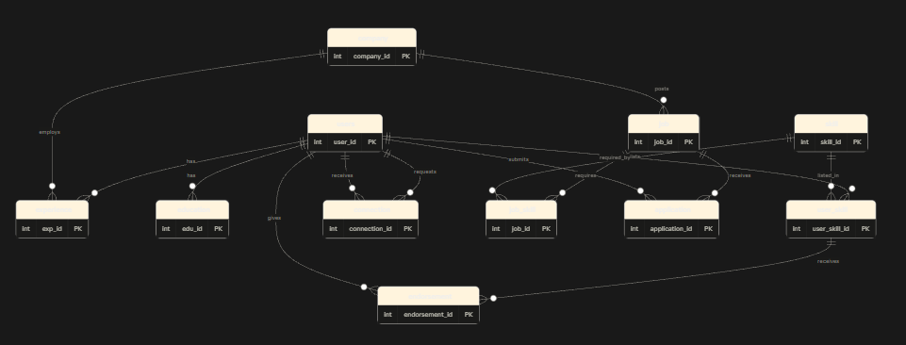

Relational Schema
Relation | Primary Key | Important Foreign Keys / Constraints
Users | user_id | email UNIQUE; application adds password_hash and is_admin at runtime.
company | company_id | name UNIQUE
experience | exp_id | user_id → users; company_id → company; end_date ≥ start_date
education | edu_id | user_id → users
Skill | skill_id | name UNIQUE
user_skill | user_skill_id | user_id → users; skill_id → skill; UNIQUE(user_id, skill_id)
endorsement | endorsement_id | user_skill_id → user_skill; endorser_id → users; UNIQUE(user_skill_id, endorser_id)
connection | connection_id | requester_id and receiver_id → users; status ENUM; requester_id <> receiver_id
Job | job_id | company_id → company; job_type ENUM
job_skill | (job_id, skill_id) | job_id → job; skill_id → skill; composite primary key
application | application_id | job_id → job; user_id → users; UNIQUE(job_id, user_id)
v_connections | View | Accepted connections exposed in both directions; not a base entity.

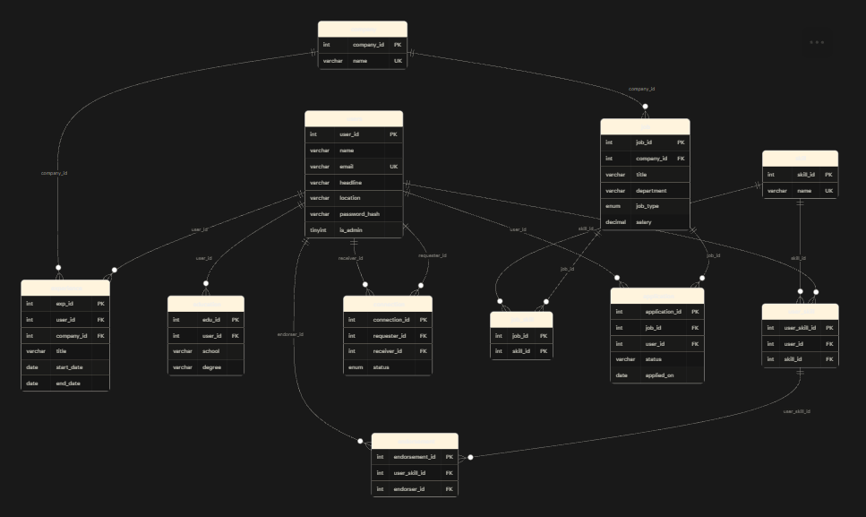

SQL DDL Statements
CREATE DATABASE mini_linkedin;
USE mini_linkedin;
CREATE TABLE users (
user_id INT AUTO_INCREMENT PRIMARY KEY,
name VARCHAR(100) NOT NULL,
email VARCHAR(120) NOT NULL UNIQUE,
headline VARCHAR(150), location VARCHAR(80)
);
CREATE TABLE user_skill (
user_skill_id INT AUTO_INCREMENT PRIMARY KEY,
user_id INT NOT NULLkill_id INT NOT NULL,
UNIQUE (user_id, skill_id),
FOREIGN KEY (user_id) REFERENCES users(user_id) ON DELETE CASCADE,
FOREIGN KEY (skill_id) REFERENCES skill(skill_id)
);
CREATE TABLE connection (
connection_id INT AUTO_INCREMENT PRIMARY KEY,
requester_id INT NOT NULL, receiver_id INT NOT NULL,
status ENUM('pending','accepted','rejected') NOT NULL DEFAULT 'pending',
UNIQUE (requester_id, receiver_id),
FOREIGN KEY (requester_id) REFERENCES users(user_id) ON DELETE CASCADE,
FOREIGN KEY (receiver_id) REFERENCES users(user_id) ON DELETE CASCADE,
CHECK (requester_id <> receiver_id)
);
CREATE INDEX idx_conn_receiver ON connection(receiver_id, status);
CREATE INDEX idx_job_dept ON job(department);
CREATE OR REPLACE VIEW v_connections AS
SELECT requester_id AS user_id, receiver_id AS friend_id
FROM connection WHERE status='accepted'
UNION
SELECT receiver_id, requester_id
FROM connection WHERE status='accepted';
DELIMITER //
CREATE PROCEDURE skill_gap(IN p_user INT)
BEGIN
SELECT j.job_id, j.title, c.name AS company,
COUNT(js.skill_id) AS required,
COUNT(us.skill_id) AS you_have,
ROUND(100 * COUNT(us.skill_id) / COUNT(js.skill_id), 0) AS match_pct,
GROUP_CONCAT(CASE WHEN us.skill_id IS NULL THEN s.name END SEPARATOR ', ') AS missing_skills
FROM job j JOIN company c ON c.company_id=j.company_id
JOIN job_skill js ON js.job_id=j.job_id JOIN skill s ON s.skill_id=js.skill_id
LEFT JOIN user_skill us ON us.skill_id=js.skill_id AND us.user_id=p_user
GROUP BY j.job_id ORDER BY match_pct DESC;
END //
DELIMITER ;
ALTER TABLE users ADD COLUMN password_hash VARCHAR(255) NULL;
ALTER TABLE users ADD COLUMN is_admin TINYINT(1) NOT NULL DEFAULT 0;

SQL DML Statements
INSERT INTO users(name,email,headline,location)
VALUES ('Aarav Shah','aarav.shah@example.com','DevOps Engineer','Hyderabad');
SELECT department, COUNT(*) AS openings,
ROUND(AVG(salary),2) AS avg_salary_lpa
FROM job GROUP BY department ORDER BY avg_salary_lpa DESC;
SELECT s.name AS skill, COUNT(e.endorsement_id) AS endorsements
FROM skill s JOIN user_skill us ON us.skill_id=s.skill_id
JOIN endorsement e ON e.user_skill_id=us.user_skill_id
GROUP BY s.skill_id ORDER BY endorsements DESC LIMIT 5;
SELECT j.title, c.name AS company, COUNT(a.application_id) AS applications
FROM job j JOIN company c ON c.company_id=j.company_id
LEFT JOIN application a ON a.job_id=j.job_id
GROUP BY j.job_id ORDER BY applications DESC;
SELECT status, COUNT(*) AS total
FROM application GROUP BY status;
CALL skill_gap(2);
CALL recommend_connections(2);
INSERT IGNORE INTO application(job_id,user_id,status,applied_on)
VALUES (%s,%s,'applied',CURDATE());
UPDATE connection SET status='accepted'
WHERE requester_id=%s AND receiver_id=%s AND status='pending';

NoSQL/ Vector Database Commands

Redis Commands
Redis is used as a NoSQL data store for social activity. The implementation uses hashes, sets, lists and sorted sets. Example inspection and reporting commands from redis_queries.txt:
redis-cli -n 1
ZREVRANGE lb:posts:likes 0 4 WITHSCORES
ZREVRANGE tags:trending 0 4 WITHSCORES
ZREVRANGE lb:commenters 0 4 WITHSCORES
HGETALL post:1
SMEMBERS post:1:likes
LRANGE post:1:comments 0 -1
ZUNIONSTORE tmp:feed 3 user:1:posts user:3:posts user:11:posts AGGREGATE MAX
ZREVRANGE tmp:feed 0 4
DEL tmp:feed

Neo4j / Cypher Model
Neo4j stores graph nodes and relationships synchronized from MySQL. The project creates User, Company, Skill, School and Job nodes. Relationships include CONNECTED_TO, REQUESTED, WORKED_AT, STUDIED_AT, HAS_SKILL, ENDORSED, POSTED, REQUIRES and APPLIED_TO.
MATCH (u:User)-[:CONNECTED_TO]-(f:User)
RETURN u.name, count(DISTINCT f) AS degree
ORDER BY degree DESC LIMIT 6;
MATCH (x:User {id:$a}), (y:User {id:$b})
MATCH p=shortestPath((x)-[:CONNECTED_TO*..8]-(y))
RETURN [n IN nodes(p) | n.name] AS names, length(p) AS hops;
MATCH (me:User {id:$uid})-[:CONNECTED_TO]-(f:User)-[:CONNECTED_TO]-(s:User)
WHERE s <> me AND NOT (me)-[:CONNECTED_TO]-(s)
RETURN s.name, count(f) AS mutual_connections
ORDER BY mutual_connections DESC LIMIT 5;
MATCH (a:Company)<-[:WORKED_AT]-(u:User)-[:WORKED_AT]->(b:Company)
WHERE a.name < b.name
RETURN a.name, b.name, count(DISTINCT u) AS people;

Results
The project ZIP contains application source code, schema and seed scripts, Redis and Neo4j initialization scripts, and reporting queries. It does not include captured runtime screenshots or a test-results export. The following are the implementation outcomes supported by the source files; screenshots should be captured from a running instance before final submission.
Feature / Result | Evidence in project
Signup and login | auth.py: signup and login routes; password hashes stored in users.
People and connections | /people, /connect and /respond routes; connection states pending/accepted/rejected.
Social feed | app.py uses Redis hashes, sets, lists and sorted sets for posts, likes, comments and feed ordering.
Jobs and applications | /jobs and /apply routes; SQL joins compare required skills with the current user's skills.
Skill-gap analyzer | skill_gap stored procedure returns match percentage and missing skills.
People-you-may-know | recommend_connections procedure scores mutual connections, shared skills and same-school matches.
Graph reports | Neo4j Cypher reports for graph statistics, degree, paths, recommendations and company/skill patterns.
Access control | login_required protects user pages; admin_required protects reports and graph API.

Evaluation Rubrics

# | Criteria | Distribution | Status
1 | Database Design | ER diagram , relational schema with keys, relationships, and constraints
2 | Database Creation | SQL database implementation - DDL with constraints , NoSQL/Vector database creation , Technology justification
3 | SQL Operations and Queries | DML operations , Nested/correlated/Recursive SQL queries, Join SQL queries
4 | Advanced Database Concepts | Advanced database concepts (Procedure/function, trigger, CTE) , NoSQL/Vector feature RUD
5 | Web Application and Database Integration | Next.js interface , Backend/API and database integration
6 | Authentication and Authorization | Authentication implementation (front end and backend) and minimum two roles and role-based access control in database
7 | Documentation, Git/GitHub, Demonstration, Testing, and Originality | Documentation, Git/GitHub , Originality and individual contribution

